**Application Process Document:**

**XYZ Module**

**Version XX**

Revision History

This document has been revised by:

|  |  |  |  |
| --- | --- | --- | --- |
| Revision Number | Revision Date | Summary of Changes | Author |
| v1 | **-**-20** | Updated chapter x | Technical Writer |
| v2 | **-**-20** | Updated chapter x | Technical Writer |
| v3 | **-**-20** | Updated chapter x | Technical Writer |

Table of Contents

1. Overview 4

2. Technical Specifications 5

2.1. Tech-Overview 5

2.2. Application Technology (XYZ Software) 6

3. System Architecture 7

4. Application Architecture 8

5. Customer Enrolment 10

5.1. Core Entities in Customer Enrolment 10

6. Events/Exception Handling 11

6.1. Why Does It Happen? 11

6.2. Error Code 11

6.3. Log Level 11

# Overview

XYZ is a flag-ship software managed by ABC Inc. that mainly targets the transporters and logistical segments. This program is designed as a closed loop software that manages the transportation and logistical requirements of ABC Inc.’s customers.

# Technical Specifications

## Tech-Overview

XYZ Software is a web-enabled system facilitating the transportation of goods from one location to another based on customer’s requirements across multiple countries. The end users are customers & the logistical outlets.

The Host is a centralized entity that manages all storage and processes of the system.

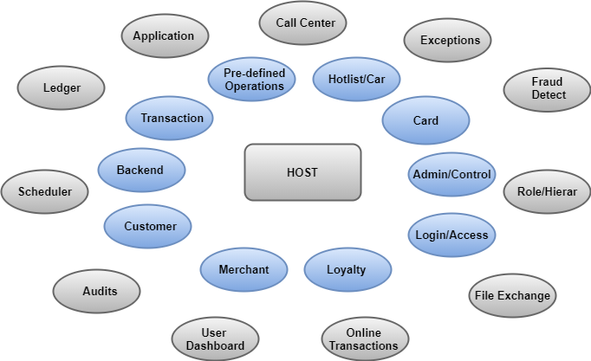

## Application Technology (XYZ Software)

The XYZ Software system is built on Angular (Web Framework) version 6 with a database backend stored in Microsoft SQL Server 2019. Mobile technologies are iOS and Android respectively. IIS is deployed to host XYZ Software system at server end.

**Other Development Platforms:**

* **.NET Framework 4.8** – Provides the managed code runtime and development platform.
* **ASP.NET** – Feature rich web application platform built in to .NET 2.0.
* **AJAX** – Extension 1.0 for ASP.NET 4.8
* **Visual Studio 16.0 for ASP.NET 4.8** – Advanced developer toolset for building rich applications rapidly and with high quality. For programs that wish to upgrade to VS2016 and ASP.NET 4.8, we tested the upgrade using the Visual Studio conversion tool and did not encounter any issues.
* **Object Persistence Layer** – Decouples application from database storage. Developers develop using objects and this layer handles the O/R (object-relational) mapping of objects to the database, as well as the implementation details of specific databases. Provides for rapid application development and ease of maintenance.
* **SQL Server 2019** – Advanced relational database management system provides high performance storage, processing, and retrieval of complex business information.

**API Development:**

* **Platform APIs:** .NET
* **External APIs:** .NET/Python

# System Architecture

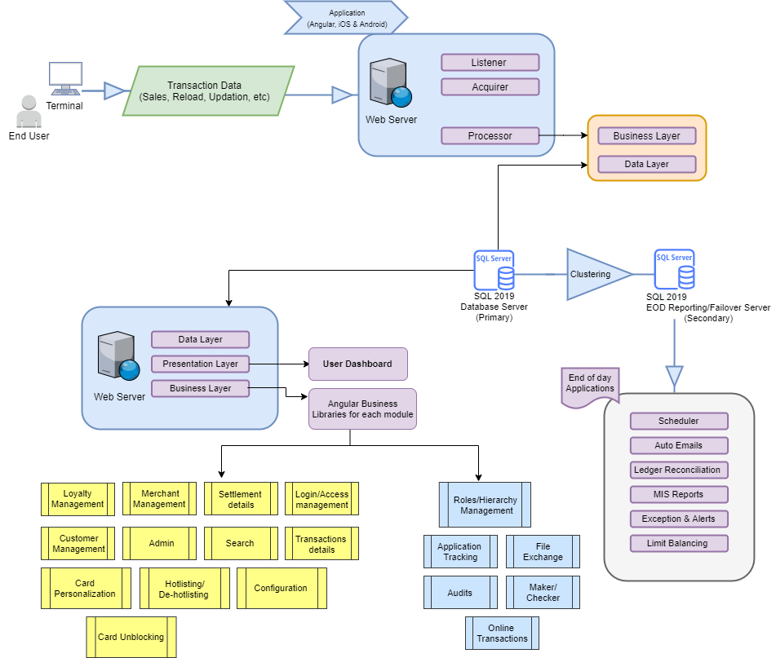

# Application Architecture

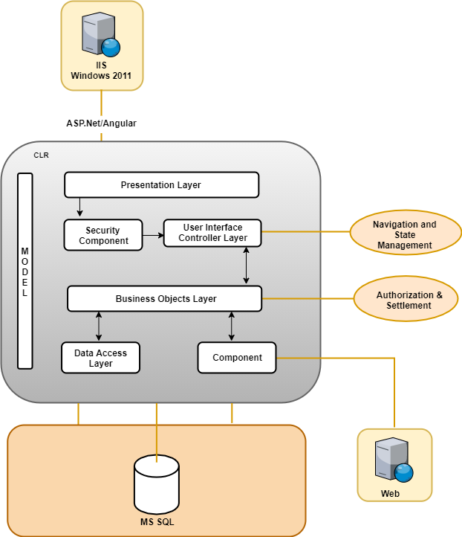

# Customer Enrolment

A Customer can get enrolled into the system through the given modes. Since the software is designed for customers, non-customers, outlets, corporate customers, etc.; they can select their designated way to get enrolled.

## Core Entities in Customer Enrolment

**End User** – End users for XYZ Software system can be categorized as Logistics Customers, Fleet Customers, Non-fleet Customers, Logistics Outlet, Corporate Customers.

# Events/Exception Handling

For any development environments errors and exceptions are commonly encountered. Some exceptions can be generated during compilation and can be handled. Others occur due to abrupt behavior of the system which can be controlled and a formatted error message should be given to the end user.

## Why Does It Happen?

* Exception is thrown by a controller action which returns an object result (not a view result).
* The request is an AJAX request with some header information.
* Client explicitly accepts the application/json content type.
* If the exception is handled, it is automatically logged and a formatted message sent.

## Error Code

{

"error": {

"code": "100562",

"message": "This topic is locked and cannot add a new

Message”

}

}

## Log Level

Exceptions are logged with the Error level by default. The Log level can be determined by the exception if it implements the “ItHasLogLevel” interface. Example:

public class MyException: Exception, ItHasLogLevel

{

public LogLevel LogLevel {get; set;} =

LogLevel.Warning;

//... }